Operations Management Suite

-

Log Analytics Labs



Browser based workplace

Hands-on lab

Workspace365 & Office365





Monday, November 20, 2017

Version 2.0

*Prepared by*

Gino van Essen & Gido Veekens

Technical Cloud Consultants – Copaco Nederland

*Contributors*

Gino van Essen

Gido Veekens

## Document Revision

## Change Record

|  |  |  |  |  |
| --- | --- | --- | --- | --- |
| Date | Author | Version | Change Reference |  |
| August 24, 2017 | Gino van Essen | 0.1 |  |  |
| September 19,2017 | Gino van Essen | 1.0 |  |  |
| November 21 ,2017 | Gino van Essen | 2.0 |  |  |
| Reviewers |  |  |  |  |
| Name | Version Approved | | Position | Date |
| Gido Veekens | 0.1 | |  | September 17,2017 |

|  |  |  |  |
| --- | --- | --- | --- |
| Gido Veekens | 2.0 |  | November 21,2017 |

Table of Contents

Document Revision 3

Change Record 3

User management - Importing users from Office365 5

Application - Single Sign-on setup 6

Applications – Add SaaS applications 9

Create user groups 13

Permission - Setting the App permissions 19

Applications - Launching Local applications 20

Applications - Add new apps to the Workspace 22

Applications - Edit app 23

Branding your Workspace 24

Restore default branding 25

Templates 26

Extra resources: 27

## Create Workspace365 environment

Go to the Copaco 2tCloud Partner portal 🡪 <https://partner.2tcloud.com/login/>

The Workspace promotion code can only be added at partner level (HostingCP) 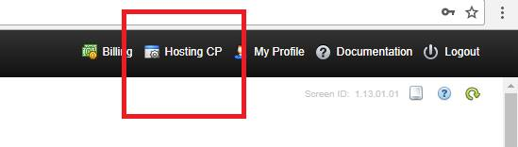

Order Workspace365 product and add the promotion code : 

The workspace365 environment will be created and will be available within minutes.

Go to the workspace365 environment via Workspace365 🡪 Manage 🡪 General 🡪 Administrator sign in

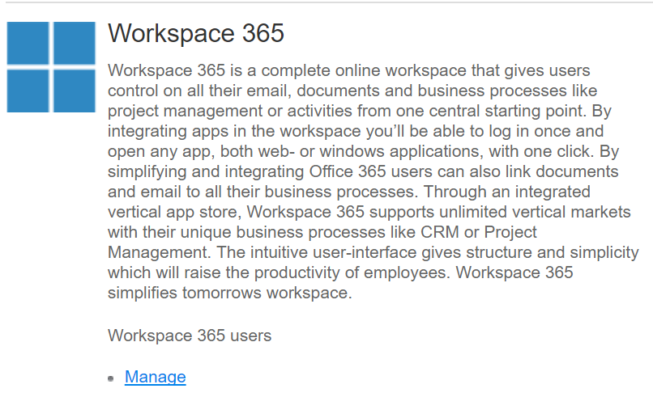

Or go to URL : workspace365.2tcloud.com/”name-of-workspace-environment”/Signin

## [User management](https://support.workspace365.net/hc/en-us/categories/201565749-User-management) - Importing users from Office365

Go to settings 🡪 User management

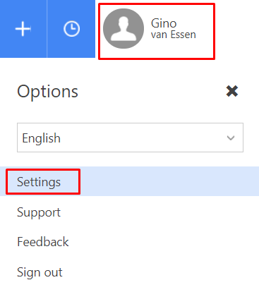

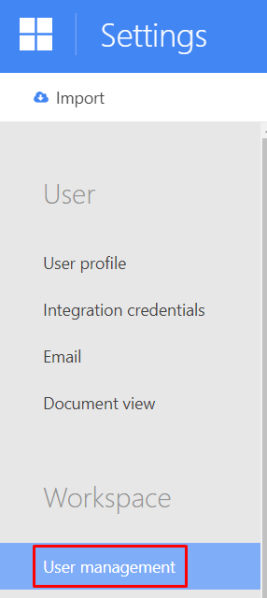

It is possible to import users from Office 365 or using a CSV from, with or without password and from Office 365. To import users from Office 365, click **Import**.

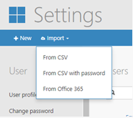

After clicking **From Office 365** you will see a list of your Office 365 users.

Select which users you want to import and click **Import**.

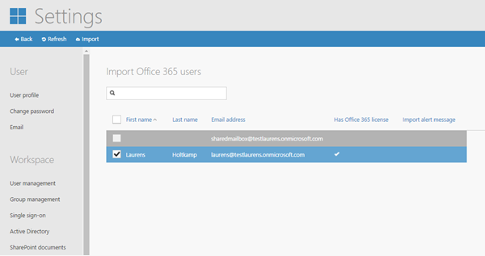

The users are now successfully imported, click **User management** to see the active users.

By default, users will receive a registration email.

## Application - Single Sign-on setup

To setup Single Sign-On automatically, choose the **Automatic setup**.

Workspace 365 will create an Azure AD application with the permissions you will grant.

By default SharePoint and Exchange are checked. Additional you can choose to add Power BI permissions to the application.

Make sure when you want to save the application, your Office 365/Azure AD password is filled in and that you check "I give Workspace 365 permissions to create an Azure AD application to provide Single Sign-On."

When you are done with this configuration, click **Done**. After you click done, you will be redirected and signed out. After you are redirected, you will get a concent of all previous set permissions. You have to accept these permissions.

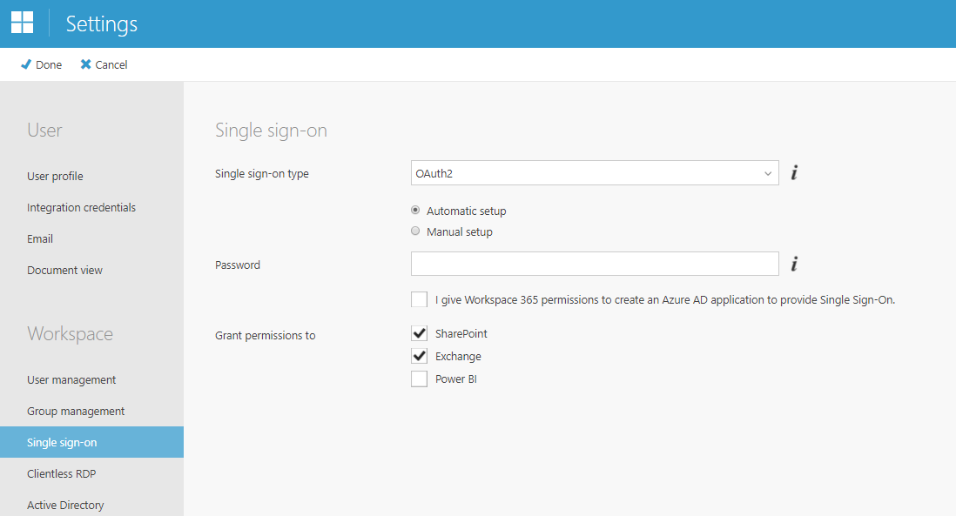

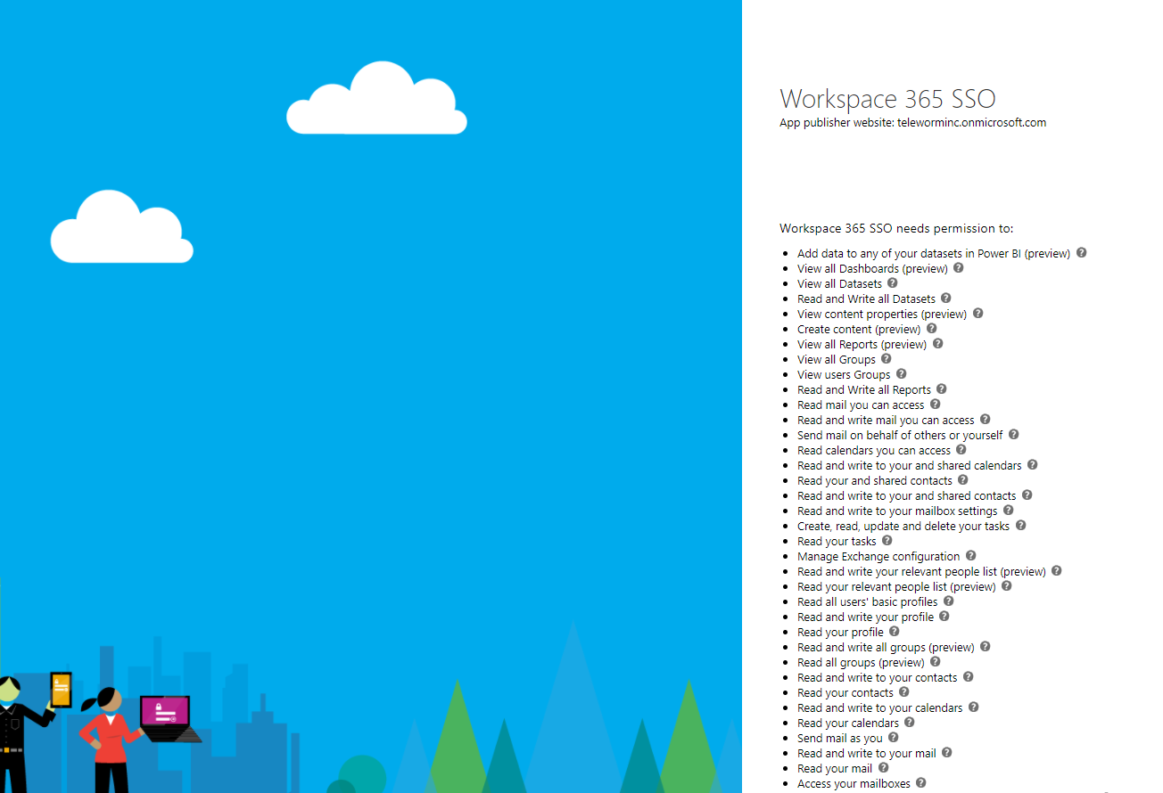

Be aware that these permissions are only granted for administrator in this tenant. You have to grant it for all users.

To grant permissions to all users, go to portal.azure.com and open Azure Active Directory. Open the automatic created Single Sign On application. The name of the application will look like {{Productname}} SSO. In this case, **Workspace 365 SSO**.

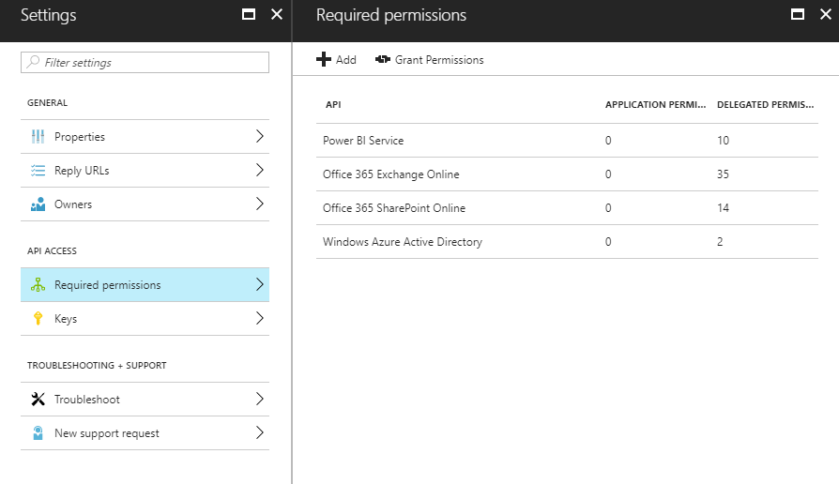

Navigate to "Required permissions" and click **Grant Permissions**

## Applications – Add SaaS applications

Add Azure Add applications and publish in Workspace365

Go to **Https://portal.azure.com**

Go to **Azure Active Directory -> Enterprise Applications ->**

|  |  |
| --- | --- |
| Click on **New Application** |  |
| Search for **Twitter** |  |
| Enter Name **Twitter** and click on **Add** |  |
| Go to “Single sign-on” 🡪 Single Sign-on Mode and switch to “Password-bases Sign-on” |  |
| Repeat the last step and add **Linkedin** |  |
| Repeat the Single Sign on Mode step |  |
| Go to workspace 365 -> Settings -> App management |  |
| Click on **Add new app** -> **Azure App** |  |
| Edit icon and copy SSO url from Azure to the Workspace365 Azure APP |  |
| Assign license to users or group |  |
| click **done** |  |
| Repeat the steps for the Linkedin App |  |

## Create user groups

In Workspace 365 you can manage individual users and their permissions to specific Apps. This is sufficient enough when having not a lot of users and/or Apps in Workspace 365.

To make this more efficient for bigger Workspace environments, User Groups and Group Permissions were added to Workspace 365 so that every Administrator is able to organize Apps and permissions to them more quickly for multiple users simultaneously.

Note: Only Workspace Administrators are able to organize User Groups, Shared App Groups and App Permissions.

All users will have permissions for the default Apps in Workspace 365, like the Documents App, Email App and Online Editor Apps. For these default Apps, permissions cannot be set. For non-default Apps, permissions must be assigned.

Go to the **Workspace** and navigate to Settings à Group Management.

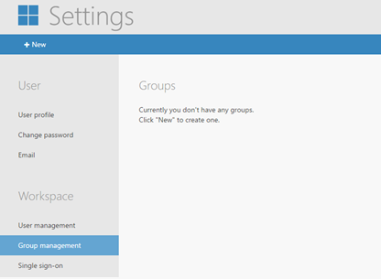

Here you will have to create your first User Group. Click **New**

By default, the Individual User list is opened. Here you can add individual users to the Group by checking their boxes and clicking **Done** afterwards.

If you have a big list of users, you can search for specific users by using the search field and selecting the users afterwards.

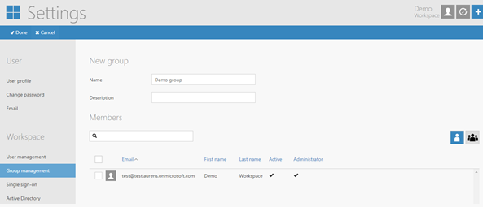

You can also switch to already existing User Groups which also can be added to the currently opened Group if needed by switching between the group or user icon.



When completed all preparations of the Group, click **Done**. You will now be redirected to the Groups overview (you can open the Group to find all specifics).

**Change the order of a group**

The order of the groups within Workspace can be changed. A user can only change the order of their personal groups. An admin can change the order of shared groups.

As a user, click **Edit your workspace**.

On the bottom of a group two arrows appear. To change the order, click left or right. Shared and personal groups cannot be mixed.

As an admin, click **Edit your workspace**.

On the bottom of a group two arrows appear for the shared groups and personal groups. To change the order, click left or right. Shared and personal groups cannot be mixed.

Workspace Administrators can create Shared App Groups containing a specific combination of Apps which can be offered to users directly. The advantages of this are:

• Users will not have to create Personal App Groups and adding Apps to it via **Add New Apps** which saves a lot of time for users.

• Administrators can fully preconfigure the Workspace and can be assured that these apps are not manually changed by users. Only Administrators can change the organization and content of Apps which are placed in Shared App Groups.

• Administrators can force these Shared App Groups to be appearing directly on the Workspace main page when a user logs in & users can hide the Group when not needed by removing the checkmark from the Group.

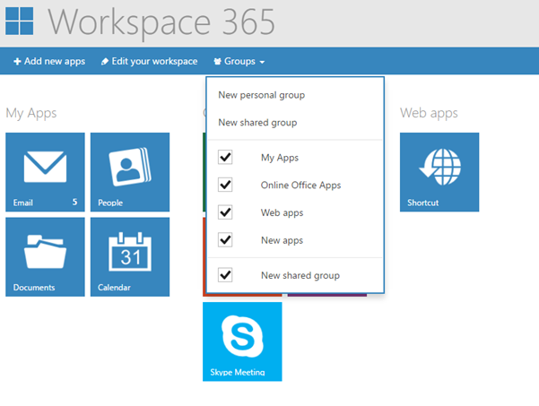

Below you can find the steps in case of setting up a Shared App Group, setting permissions and making these Shared App Groups visible on the Workspace main page for other users:

• Login as Administrator and click **Add new Apps**.

• Make sure all of the needed Apps for the Shared Apps Group are added to the main page & saved.

• Now open the **Groups** dropdown at the main page and click **New shared group**.

• A new empty group will appear on the main page, make sure the Apps are added to the Shared App Group (you can do this by drag and dropping the Apps in the Group).

• Change the Shared App Group name if needed and afterwards click **Done**.

• Now click the **User Permissions** button on the top right of the Shared App Group.

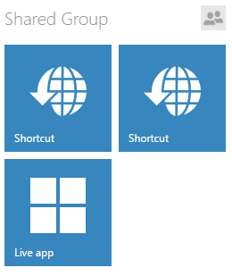

By default, the Individual User List is opened as shown here. On the right side of the screen you can switch to the User Group List. The Groups are now shown. Assign the Group by marking the checkbox which is shown.

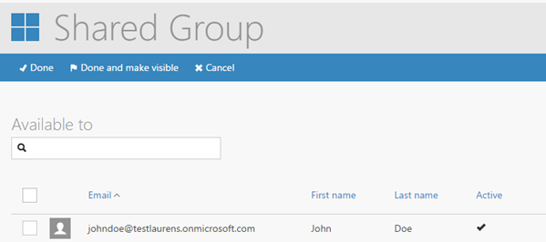

If you click **Done**, users from the User Group can find the Shared App Group by clicking the Groups button on their main page. They have to mark the checkbox to add it to the Workspace main page.

If you click **Done and make visible** you will be asked to verify if you really want to force these Shared App groups to be visible directly on the Workspace main pages of the permitted users.

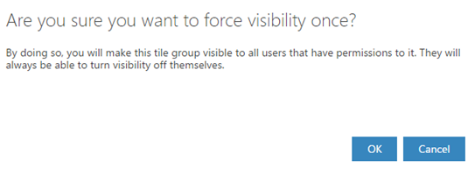

Click **OK**. The Shared App Group will be automatically added to their main pages and appear when they log in to their Workspace, which is very convenient for most users.

## Permission - Setting the App permissions

After setting up the User Group, you can continue with assigning the permissions to the Apps that need them. If you did not need or create a User Group, permission assigning to individual users will work almost identical from here on.

Navigate to **Settings** and **Apps Management** and open the specific App which needs permissions.

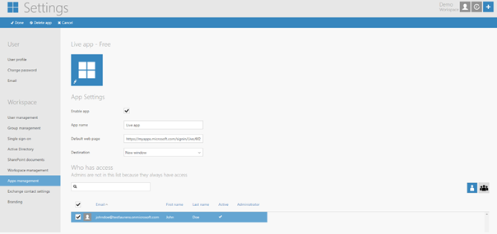

By default, the Individual user list is opened. If you want to assign permissions for individual users, you can check the boxes and save by clicking **Done**.

If you want to assign the User Group to the App, switch to the User Group list by clicking it. More User Groups will be shown here if more were created. Check the box which is shown in front of the User Group name and click **Done** afterwards. Now you have assigned User Group permissions to the App. Which means that users can now make use of the App.

Note: They can find the App by clicking **Add new Apps** at the Workspace main page if not already shared via a Shared App Group by the Administrator.

## Applications - Launching Local applications

Local apps are only accessible via Workspace on the device which they are installed to. In order to enable local applications from the Workspace, please follow these steps:

**Create .reg file**

First, a protocol must be created in the Windows registry for the local application. In this case, Notepad will be the example application we want to add and launch using the Workspace. See the example below:

Windows Registry Editor Version 5.00

[HKEY_CLASSES_ROOT\Notepadapp]

@="URL:Notepadapp"

"EditFlags"=dword:00000002

"FriendlyTypeName"="Notepadapp"

"URL Protocol"=""

[HKEY_CLASSES_ROOT\Notepadapp\shell]

@="open"

[HKEY_CLASSES_ROOT\Notepadapp\shell\open]

[HKEY_CLASSES_ROOT\Notepadapp\shell\open\command]

@="\"C:\\Program Files (x86)\\Notepad++\\notepad++.exe\""

The protocol has to be created in a .txt file. Open a new .txt file using Notepad. ‘

Copy the content of the example above, paste it into the .txt file and save the file.

Note: In case of preventing any registry conflicts, we advise you to use a unique application name at the “HKEY_CLASSES_ROOT\ “positions in the protocol as we also did in the example above (not “notepad”, but “notepadapp” for example).

The app name specified in “@=URL: notepad” and "FriendlyTypeName"="Notepad" can be the app name of your choice and does not have to be unique.

The path of the .exe file in the protocol should match the exact path of that .exe file on your local disk (see the last line in the example above). Locate your .exe file and make sure the path is correctly stated in the protocol.

The .txt file must now be changed to a .reg file. Please rename the file to a .reg file and save this. Open the registry editor on your PC (regedit.exe) and import the created .reg file in the Registry:

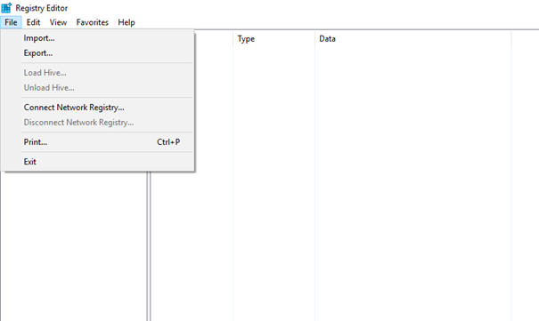

## Applications - Add new apps to the Workspace

Go to the Workspace 365 dashboard and click **Add new apps**.

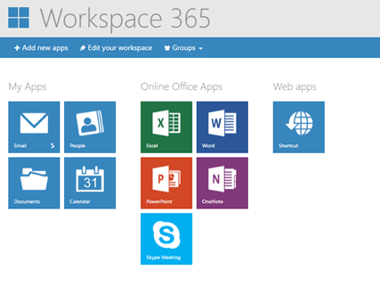

## Applications - Edit app

Select the **Shortcut**  app and click **Add to workspace**. The selected app is added to the overview.

Select the **“Shortcut”** app, Click **Edit app** in edit mode. Fill in the app name of your choice and select an icon for the tile. Fill in the following at the Webpage field

Applicationname:open

Unique name used behind [HKEY_CLASSES_ROOT\ in the protocol. Click **Done.**

The local application will now be opened by clicking the created **Shortcut** app.

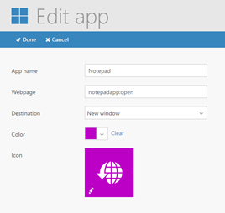

## Branding your Workspace

As an administrator you are able to easily brand Workspace 365. You can select the colors, logo and even the product name. This will give you as a partner the recognition you deserve! After completing the steps in the document, you will be able to change the branding of your Workspace.

**Branding settings page**

It is possible to brand your Workspace. This can be done by the Administrator of the Workspace. When this is created by the Administrator, the newly created design of the Workspace will automatically be set as default for all other users within the Workspace.

There are a number of possibilities when branding the Workspace:

1. You can create a Workspace name (Product Name);

2. Change the colors used in the Workspace (Color & Header Color);

3. Implement the logos of your choice (Workspace logo & Sign in logo);

4. Create solid content for the support page (Support information).

You can find the Branding options when logged in with the Administrator account, then navigate to “Settings” and “Branding”.

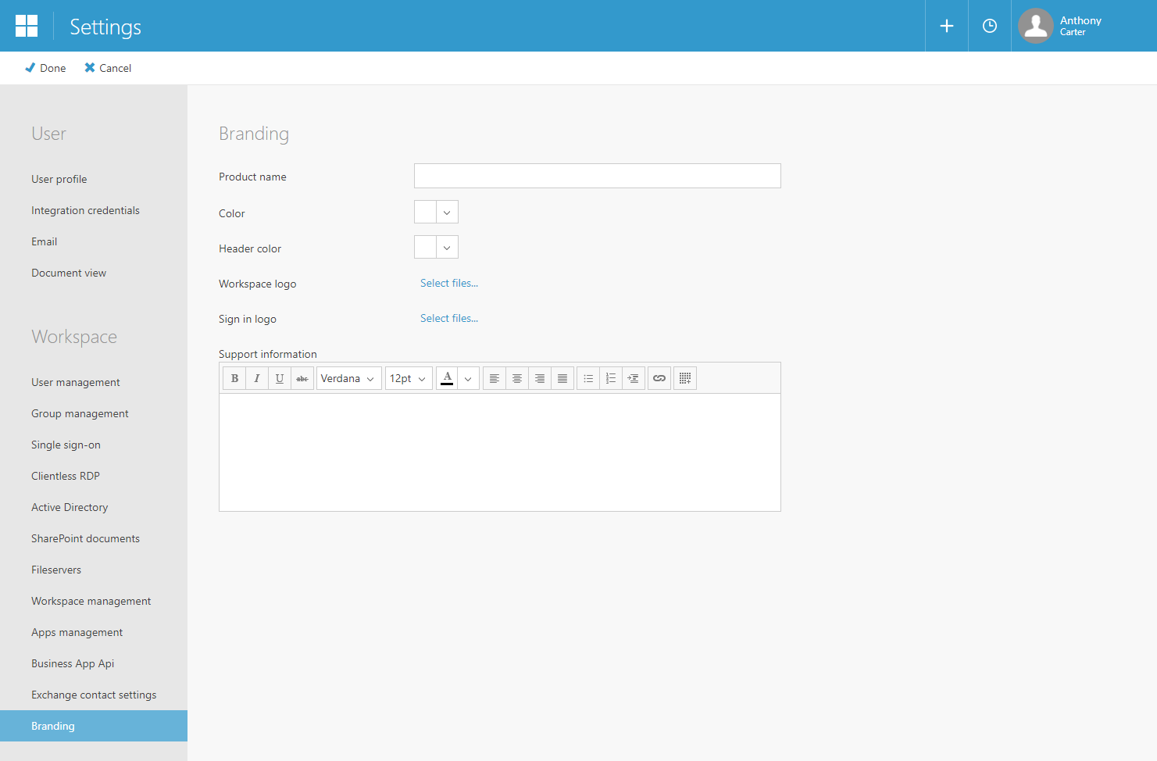

Creating your own branded Workspace is easy and can be created within minutes. When all changes are made, the only thing left to do is saving the changes. To do this, click **Done** in the upper left of the screen.

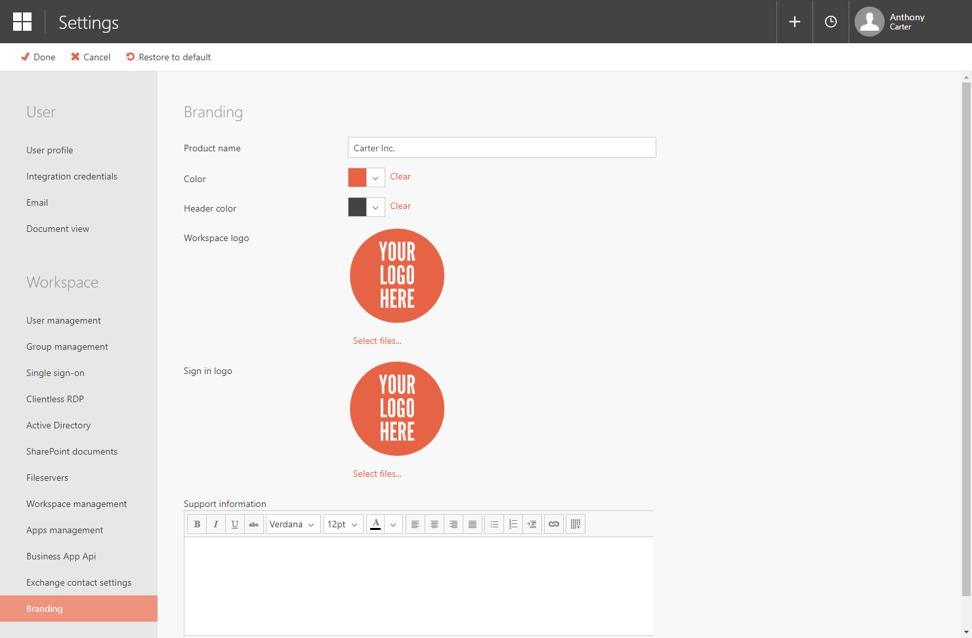

## Restore default branding

It is also possible to restore the Workspace to default branding settings. To do this, click **Restore to default** and then click **Done** in the upper left of your screen.

**Uploading logos**

The following file types are supported:

• .jpeg

• .gif

• .png

• .pjpeg

The maximum file size is 5 MB.

## Templates

It is important to learn how to set up a Workspace template. This will allow you to set up the workspaces of new users within seconds.

After completing the steps in the document, you will be able to set your workspace as a template.

As an Administrator, you can save a template of your current Workspace main page. This means the template is updated with all of the Personal App Groups that the Administrator has set in his own Workspace.

After setting the template, only new created users will have the exact same main page. Existing users will not be updated.

Note: The template contains only the Personal App Groups. Shared App Groups have to be organized in a different way explained in another document.

Log in to Workspace 365. Navigate to **Settings** -> **Workspace management**.

On this page you have the ability to choose if you want to set your workspace as a template for new users. If you make changes to your workspace you need to update the template. Click **Set my workspace as template** to do so.

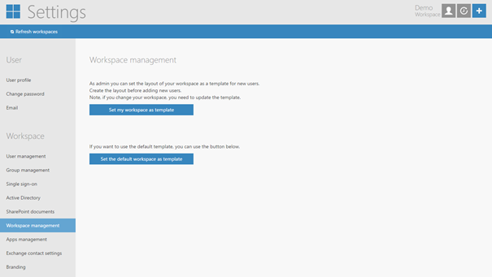

**This is the end of the lab.**

## Extra resources:

**New day @ work**

<http://www.newdayatwork.com/home/>

**New day at work support website**

<https://support.workspace365.net/hc/en-us>

**2tCloud Support knowledgebase – Workspace365**

<https://partner.2tcloud.com/kb/category/17/>